ACC’s Cultural Safety Webinar – Updates to ACC's cultural safety support resources
June 10, 2026

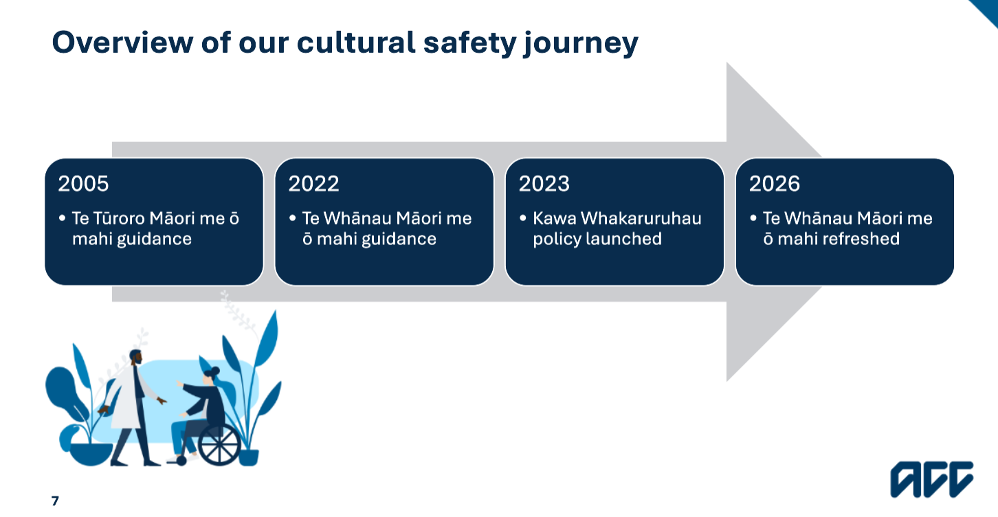2026 = launching an expanded and extended cultural guidance document.

Cultural safety vs cultural competency
While ethnicty is part of culture, ACC recognises that culture is braoder than that. Culture includes many dimentiosn of a person’s identity (e.g., ethnicty, religious beliefs, gender, sexuality, age, whether someone has a disability, and so on).

Every client brings their own unique experiences, values and perspectives, and so recognising and responding to their needs helps create environment where people feel respected, understood an safe.
Supporting culturally safe expereinces starts with understanding two related, but different concepts – cultural safety and cultural competency.
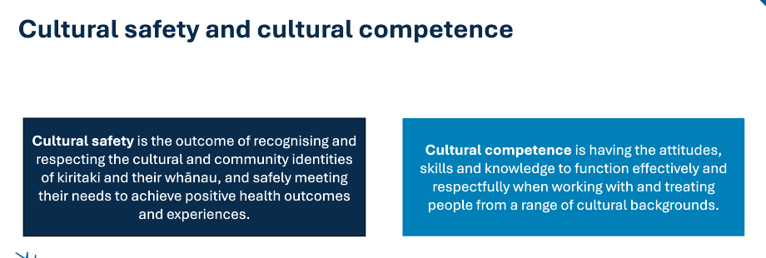

Feedback ACC has received from providers:
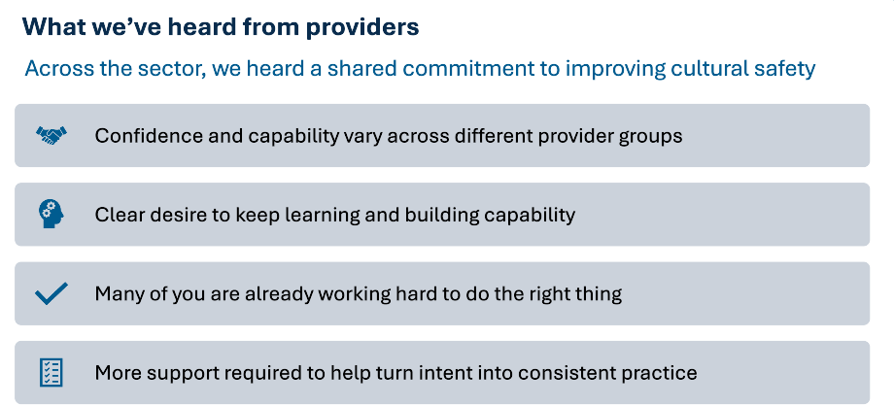

Feedback ACC has received from kiritaki and their whānau:
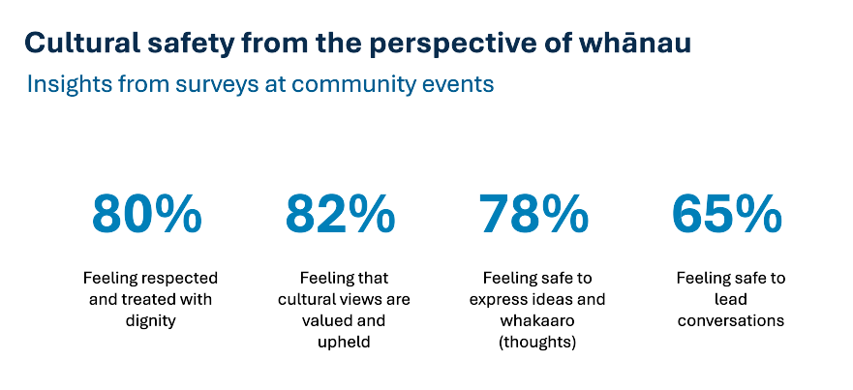
Client perspectives of cultural safety:
- Feeling respected and valued
- Treated with dignity
- Feeling that their cultural views and preferences are valued
- Feeling safe to express their thoughts
- Feeling able to participate in decisions related to their care and working in partnership with their provider
⇒ reinforces the idea that cultural safety is defined by the experience of the person receiving care.

One of ACC’s key priorities is to put clients first with care that leads to lasting recovery. We know that outcomes improve when clients are actively engaged in their recovery, and when they feel able to ask questions, understand their options, and participate in decisions. And for those things to happen, they need to experience their care is (culturally) safe.

Cultural competence = about the clinician of the individual providing care. The attitude, skills and knowledge needed to work effectivelt across cultures. It is learable and can be assessed.
Cultural safety = about whether care is experienced as safe, respectful and includive by the patient and their whānau. The focus is on trust, power, and the impoact of care. Can only be judged by the person receiving care. Could be considered an outcome measure.

From a clinical perspective, competence alone is not enough. A clinician can have a strong knowledge of cultural competence and still deliver care that feels dismissive or unsafe. When that happens, patients may share less information, disengage from care, be less likely to follow treatment, and ultimately experience worse outcomes.

Cultural safety changes the questions we ask ourselves as clinicians and is where reflective practice becomes critical.

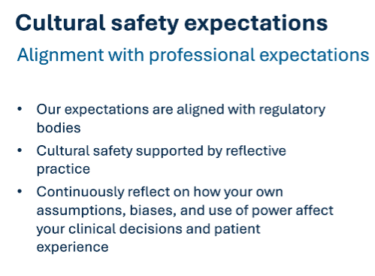

The clear shift away from cultural competence alone and towards cultural safety is supported by professional expectations from regulatory bodies. These requirements have shifted to not just be about acquiring knowledge, but to continuously reflect on how providers’ assumptions, biases and use of power may affect clinician decisions and patient experiences.

Reflective practice is not optional; it is how we demonstrate culturally safe care. It is also embedded in recertification, peer review and continuing professional development.
This expectation applies across all areas of clinical care.

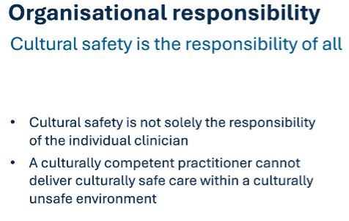
A culturally safe client experience is not just about what happens within a clinical consult. It is shaped by the whole system around a patient (i.e., cultural safety applies to both clinical and non-clinical roles/providers).

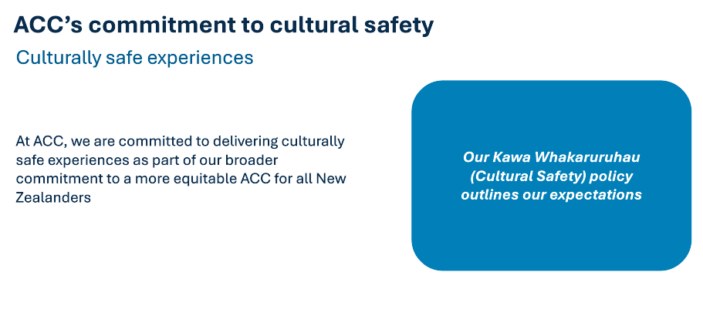
ACC’s commitment to improving culturally safe experiences for kiritaki and their whānau is part of their broader commitment to equity. These expectations are set out in the Kawa Whakaruruhau – Cultural safety policy.
ACC expects all providers to be committed to delivering equitable, culturally safe care. This includes:
- Clinical practice
- Professional development
- How you collect and use information
- How your reflect on and improve your practice

The policy aligned with Code of ACC Claimants' Rights and the Code of Health and Disability Services Consumers' Rights.


The updates to ACC’s Kawa Whakaruruhau – Cultural safety policy are not about creating additional workloads for providers, but rather about aligning with the sector direction and existing expectations.

In response to feedback that the policy needed to be more focused on what and less about why, ACC has developed two documents to sit side by side and be used together:
- Kawa Whakaruruhau: Cultural safety – this is the policy document that lays out ACC’s expectations and requirements to comply with.
- Te Whānau Māori me ō mahi: Guidance on Māori cultural competencies for providers – this document will support organisations how to align any policies or organisational process to enable culturally safe practice. This second document will also include why cultural safety is important.

No plans at this stage to change the requirements to:
- Meet or exceed professional body requirements related to cultural safety
- Cultivating cultural linkages and programmes with cultural groups
- Improve communication, understanding and trust
- Undertaking and reflecting on systematic surveys with kiritaki and their whānau to understand their experiences
- Maintaining records that demonstrate compliance with this policy

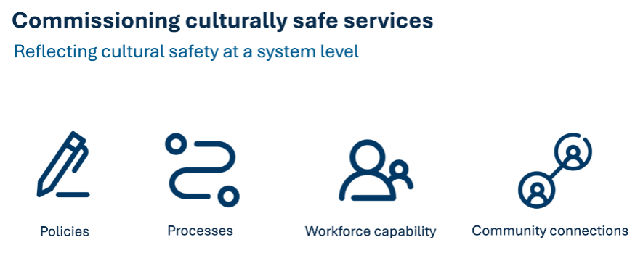
Organisations can reflect cultural safety at a system level by embedding cultural safe care across their operations. This can include, but is not limited to, four interconnected areas:
- Policies – these set the tone for designing, planning and delivering culturally safe care. They show commitment, create accountability, and define what cultural safety should look like at a governance level.
- Processes – these involve the day-to-day practices, behaviours, environment, and choices that shape a person’s experience of their care.
- Workforce capability – this can include the skills, confidence, ongoing training, and accountability of all staff and leaders to provide care that respects and responds to diverse cultural needs.
- Community connections – this involves embedding cultural safety beyond the organisation and into the communities they serve.

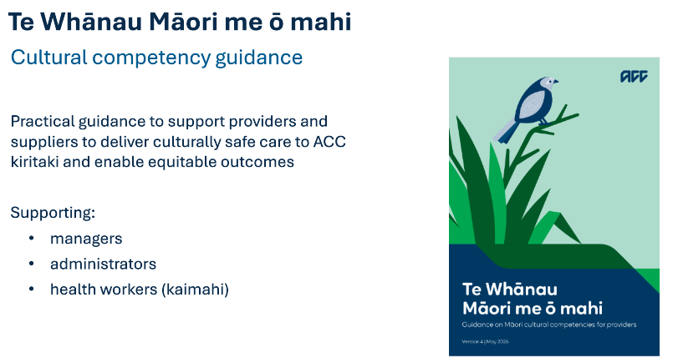
The purpose of cultural safety is not compliance for compliance sake, nor it is about becoming an expert in every culture. There is not a one size fits all Māori design.
While cultural safety can have an impact on the way we make decisions, there are also many wider issues you need to consider. It is about reflection, relationships, and continuous improvement.

Small changes in communication, engagement, and service design can significantly influence trust, participation and outcomes.


Cultural safety is not about giving some people more, it is about equity, and ensuring that nobody receives less because of the barriers they face.
The ultimate questions is not “did everyone receive the same service?’, but instead “did everyone have the same opportunity to achieve a positive outcome?”. That is the challenge of equity and cultural safety, and is why this work matters.

